“Where I’m from” Tuere Anne Marshall
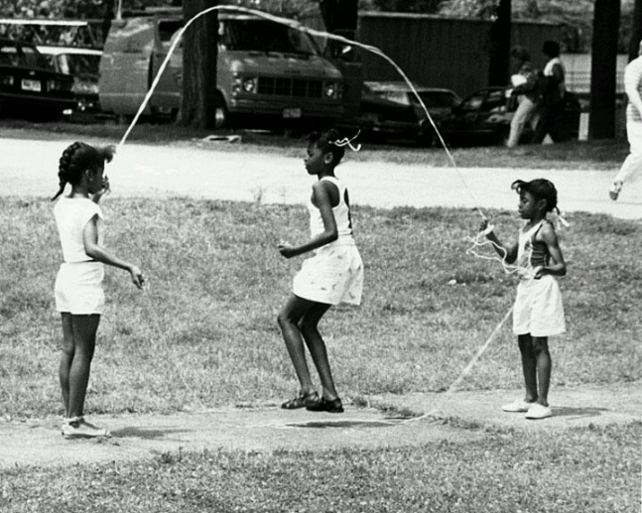
I’m from hot dogs and beans on Saturday night and fried scrapple for breakfast
I’m from Dad’s framed photos of Gloria, Sarah, Ella, Sonny, Miles, and John (Malachi)
I’m from seeing piles of incense on the basement piano and wondering why
I’m from the Wonder Bread Bakery smells floating over Georgia Avenue
I’m from Girl Scout Troop pledges, field trips, cookie sales
and eating more cookies than I sold
I’m from honey suckle and rose bushes in the yard
I’m from double-dutch and dodge ball
I’m from Catholic school days with nuns, grammar, rules,
boyfriends sneaking on the yard and girlfriends learning to hand dance
I’m from oxford loafers, white blouses and rolled-above-my-knee skirts
I’m from cheerleading, plays and glee club tryouts
I’m from Mass every Sunday morning and no-meat on Fridays
I’m from family trips to Baltimore sitting on Miss Irene’s front stoop
I’m from trips to Detroit in the Mercury station wagon
I’m from Mom’s “keep your elbows off the table this is not a horse’s stable”
I’m from Grandma’s “there’s a place for everything and keep everything in its place.”
I’m from Annie’s Hot Dog stand before Ben had his Chili Bowl
I’m from Chocolate City, Cherry Blossoms, Walter Washington, Marvin Gaye
and . . . Marion Barry
That’s where I’m from.

